Daily Assessment

Name : Chakradhar Bhogapurapu

Date : 05/01/2024

Mail : [chakribhogapurapu@gmail.com](mailto:chakribhogapurapu@gmail.com)

**Data Lake House**

Data Lake House is a combination of structured data and unstructured data. Lakehouse is a one stop destination for all your data, analytics and AI needs. It leverages the scalability and flexibility of data lakes and the reliability and performance of data warehouses, allowing organizations to store and process structured and unstructured data in a single system.

Key features of data lake house :

🡪ACID transactions

🡪Schema enforcement

🡪Version control

🡪Unified metadata management

🡪Scalability and performance

🡪Flexibility

Unity catalog:

One of the key benefits of using the Unity Catalog in a lake house architecture is that it provides a single point of access to all data assets, regardless of where they are stored. This means that users can easily discover and access data assets that are stored in different locations, such as cloud object store

**Data copy in Azure Data Factory**

Azure Data Factory is a cloud-based data integration service that allows you to create data-driven workflows in the cloud for orchestrating and automating data movement and data transformation.

How data factory works:

🡪Connect and Collect

🡪Transform and Enrich

🡪Publish

**Data Copy in Data Factory**

Search for azure data factory in search bar.

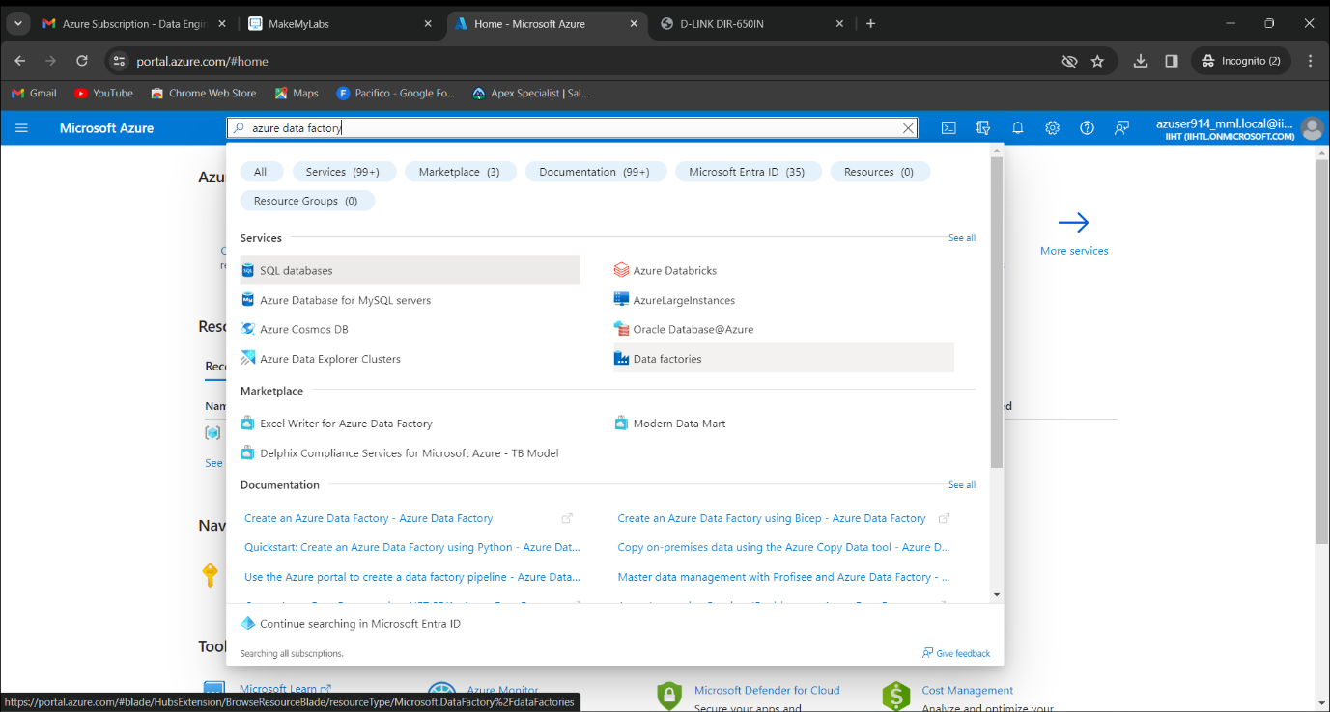

Click on create to create a data factory.

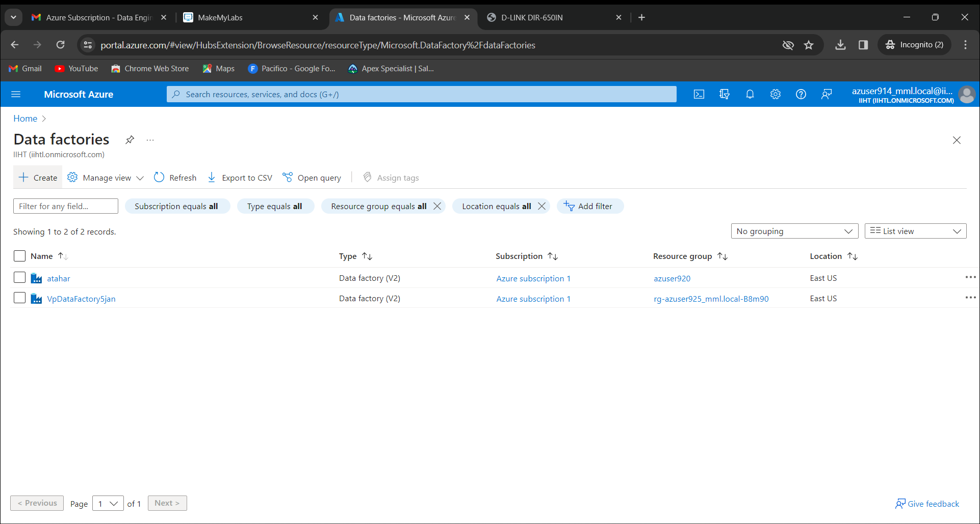

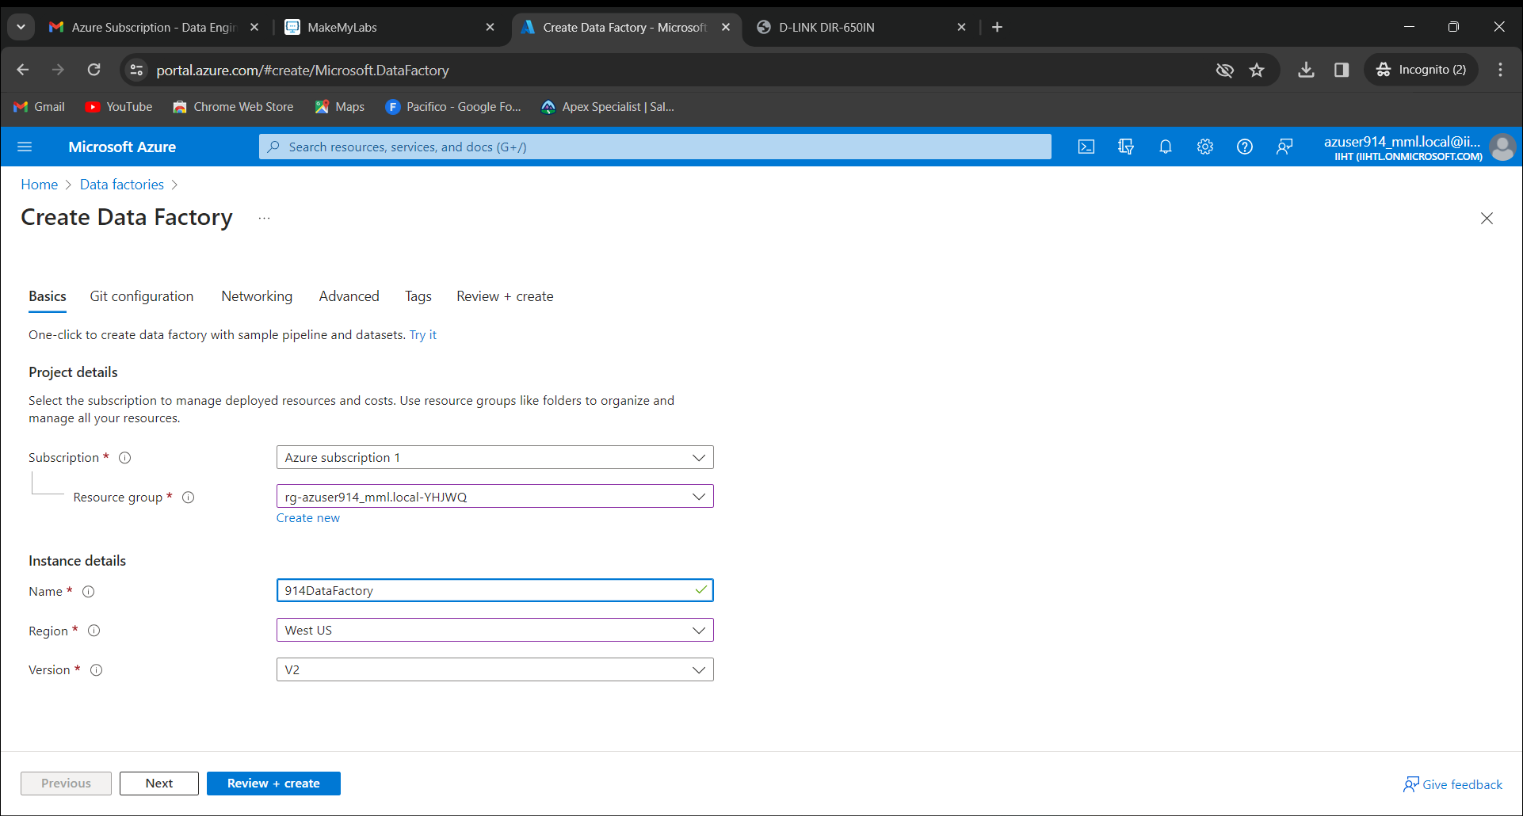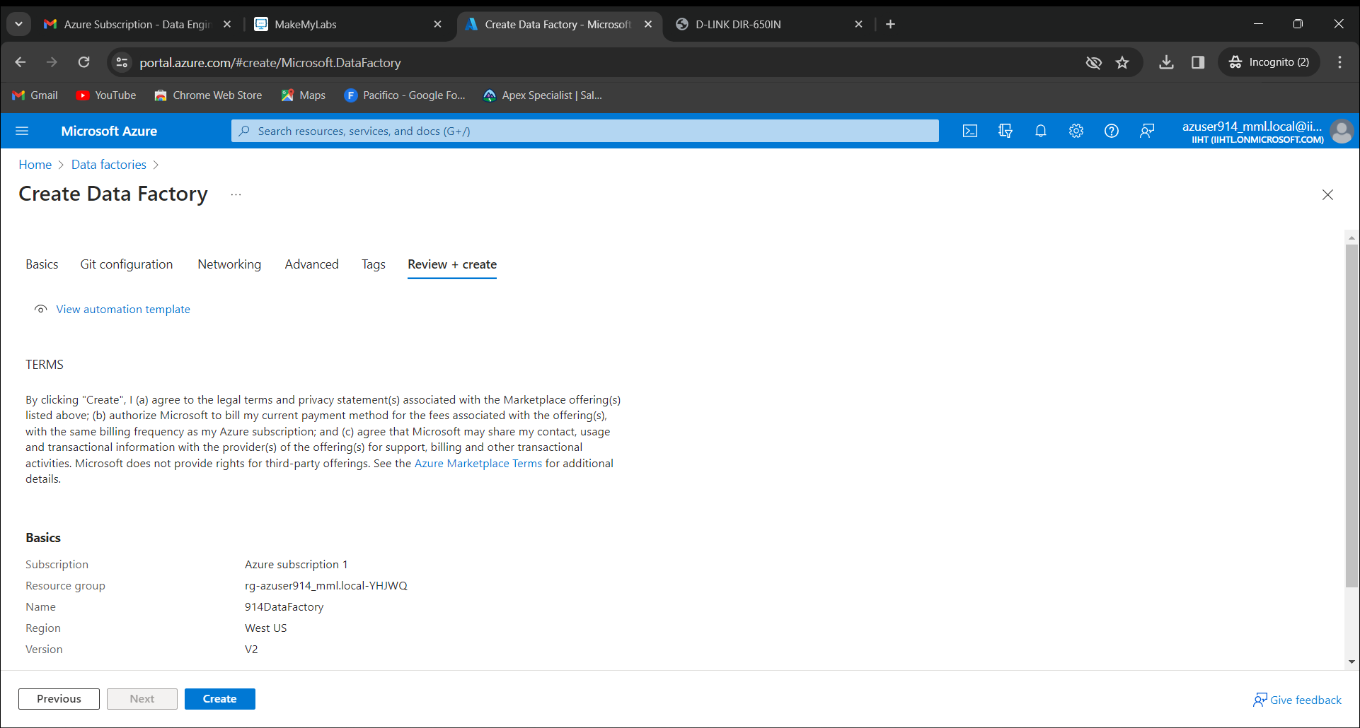

Now go to resources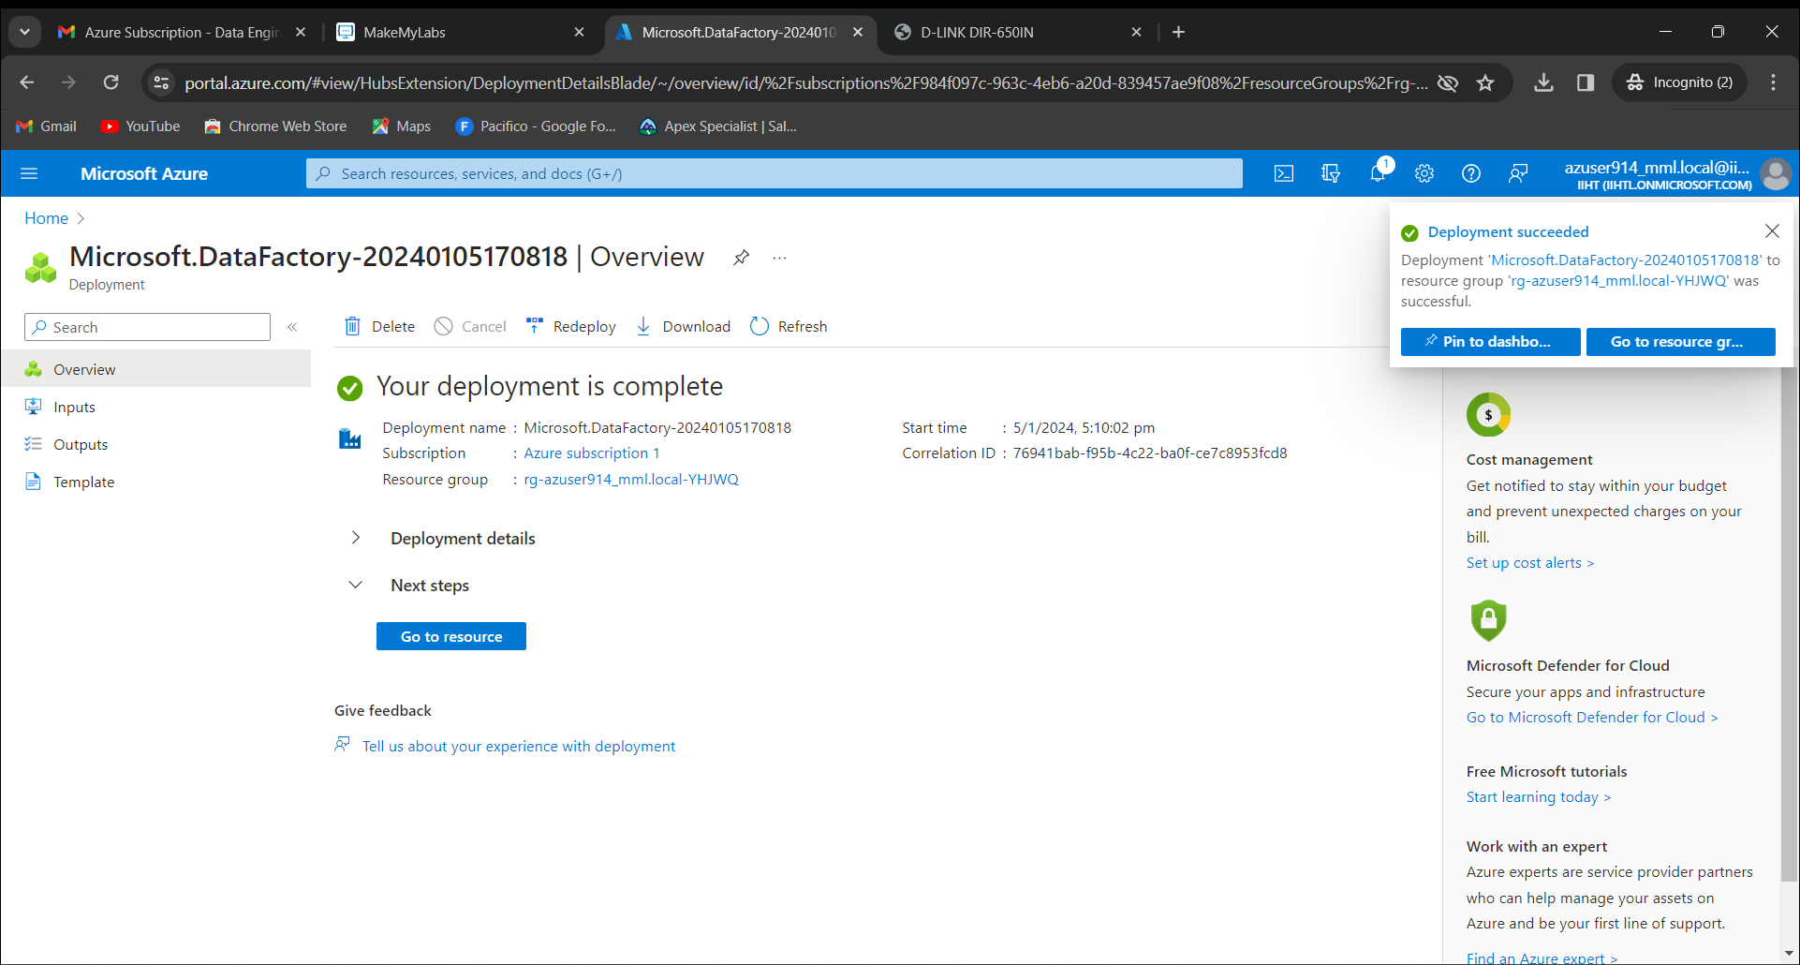

Click on launch studio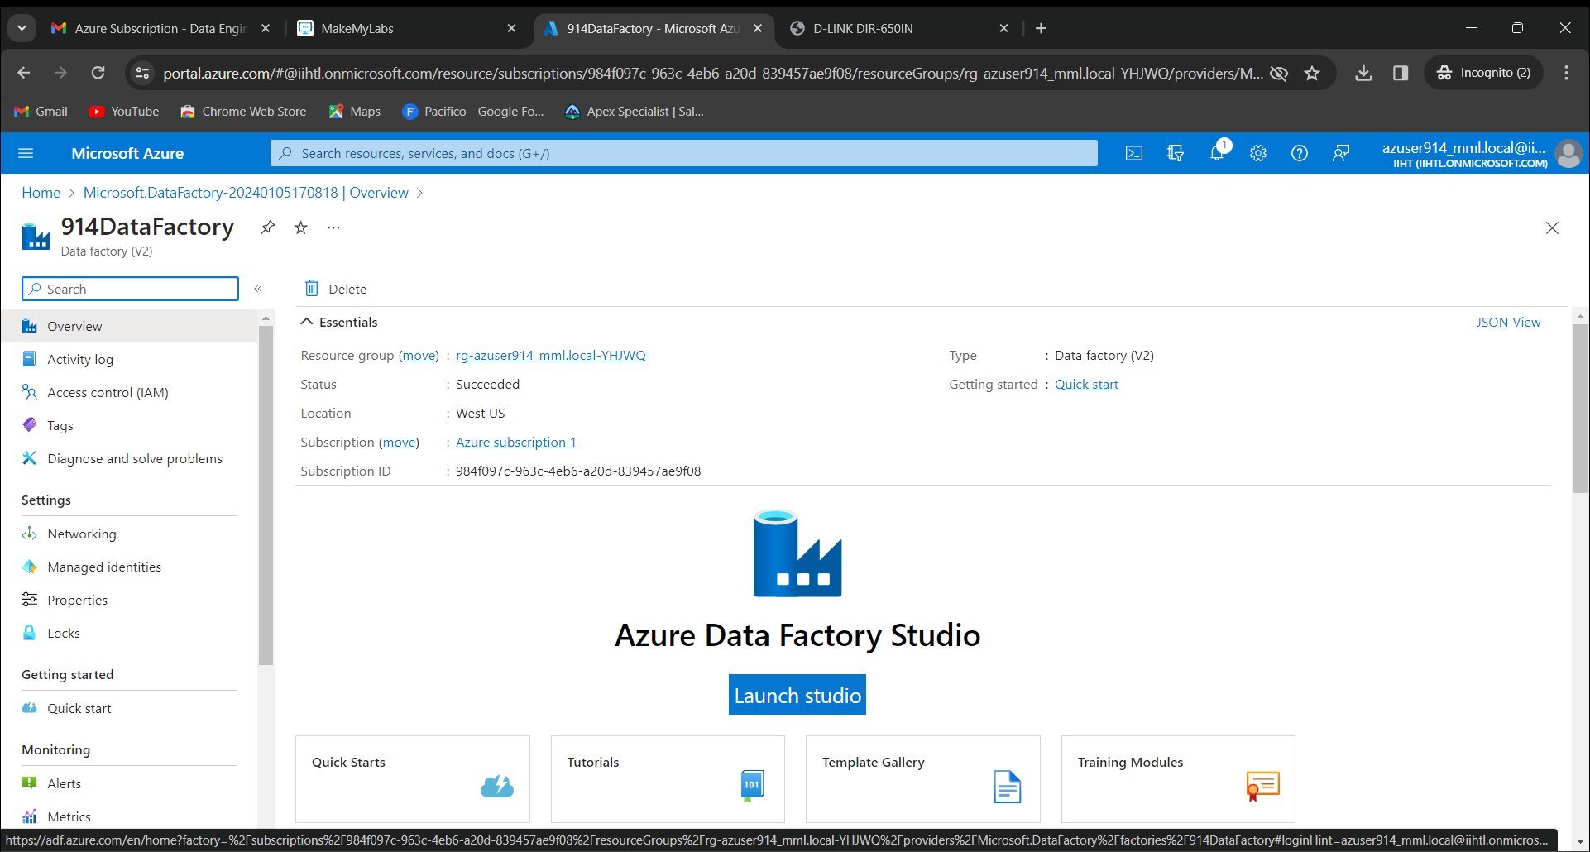

Click on New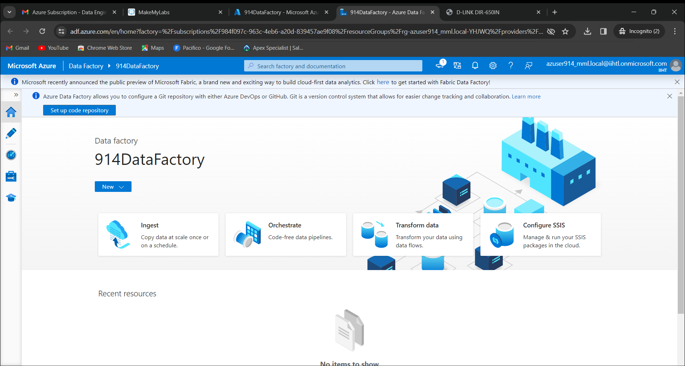

Select “Built-in copy task” and click on next

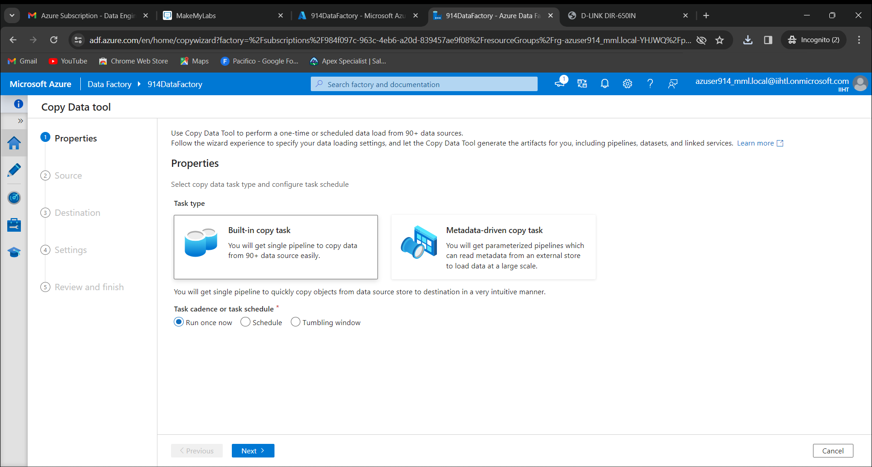

Click on “New connection” and select “Azure Blob Storage” 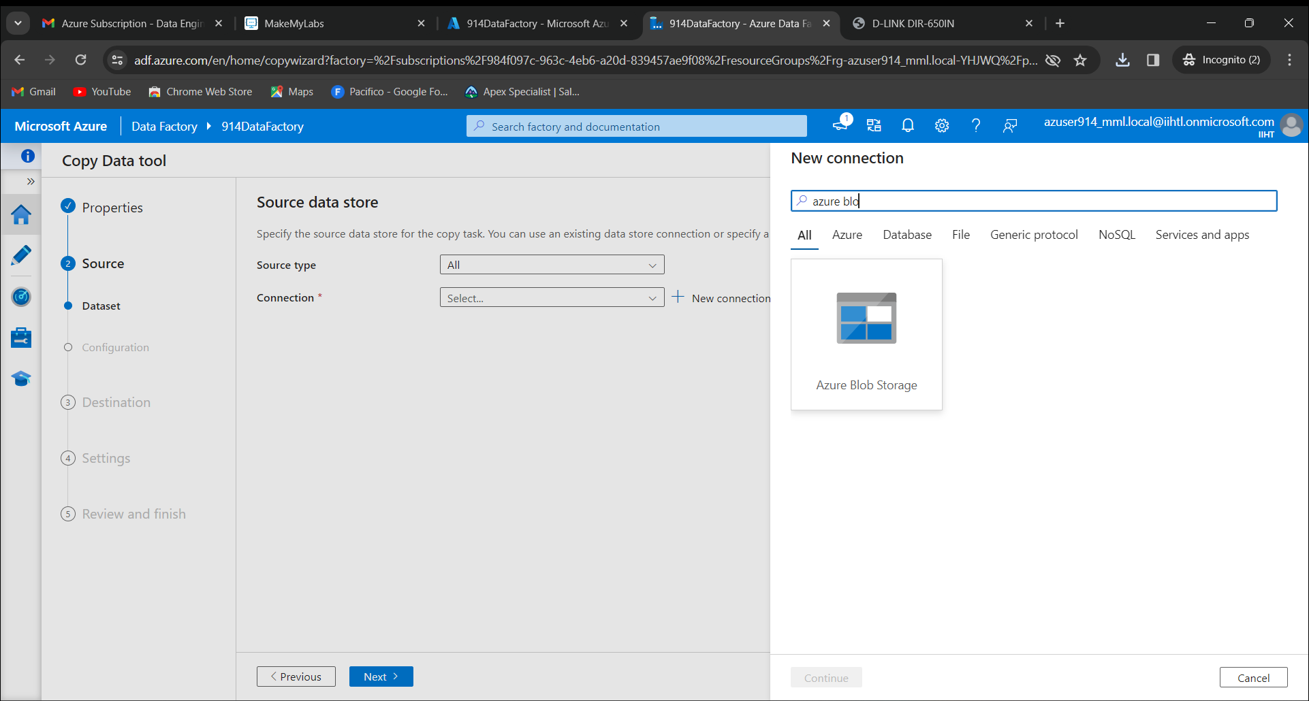

Click on create

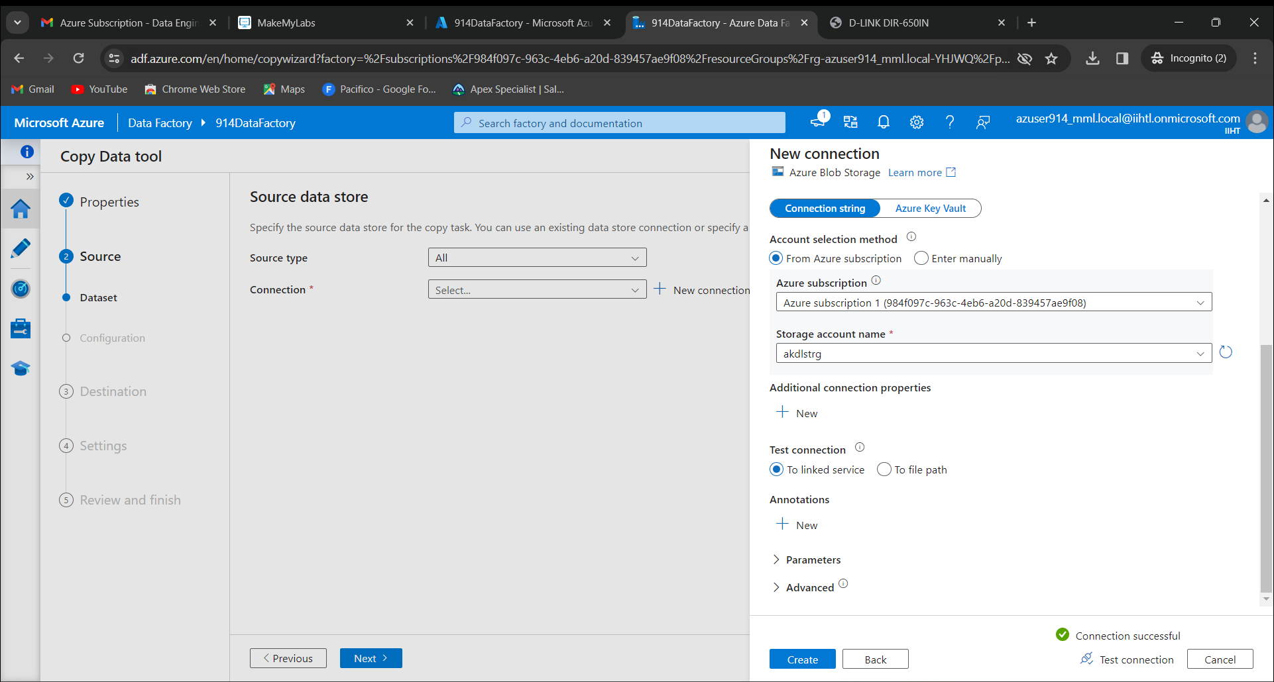

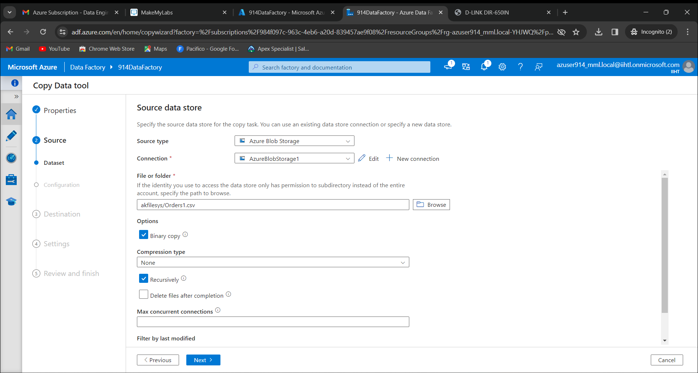

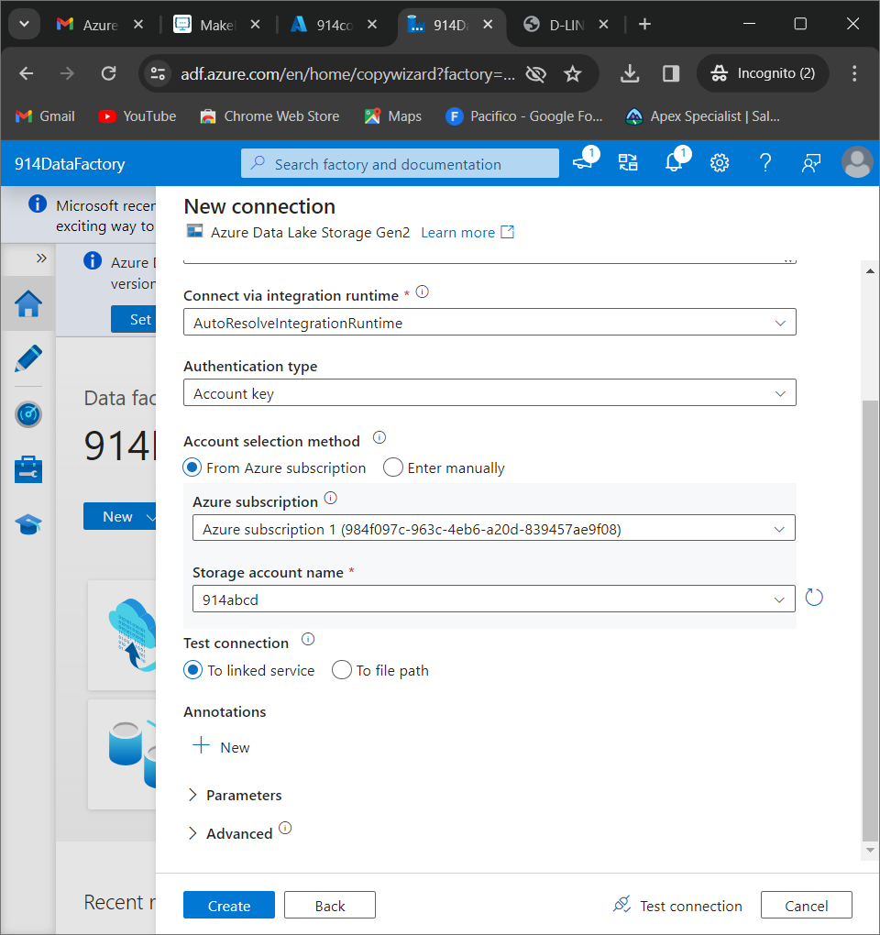

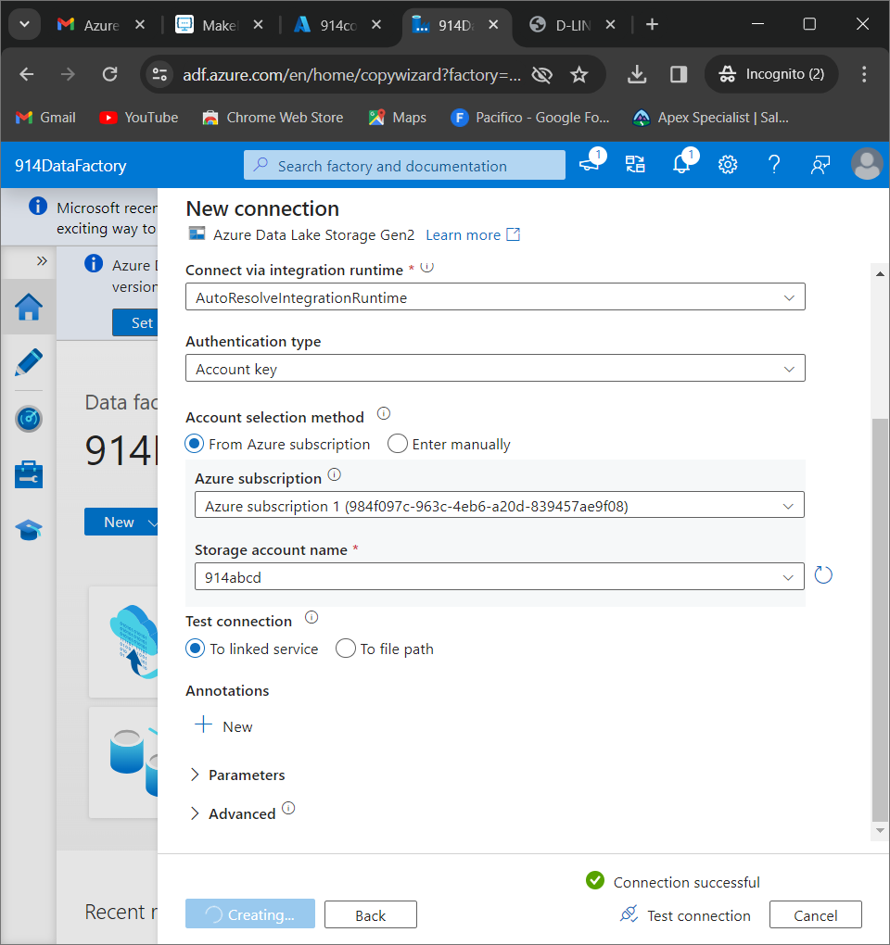

Select a container that was created earlier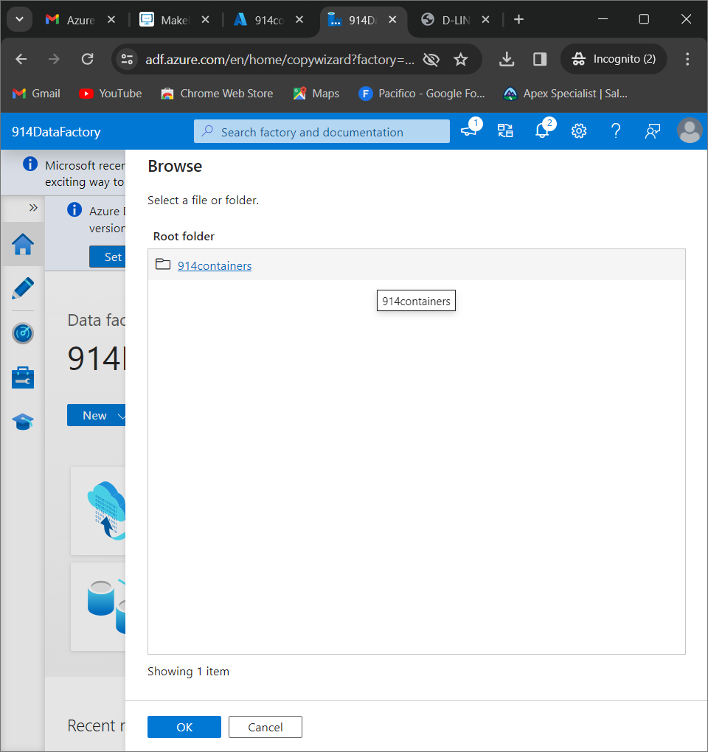

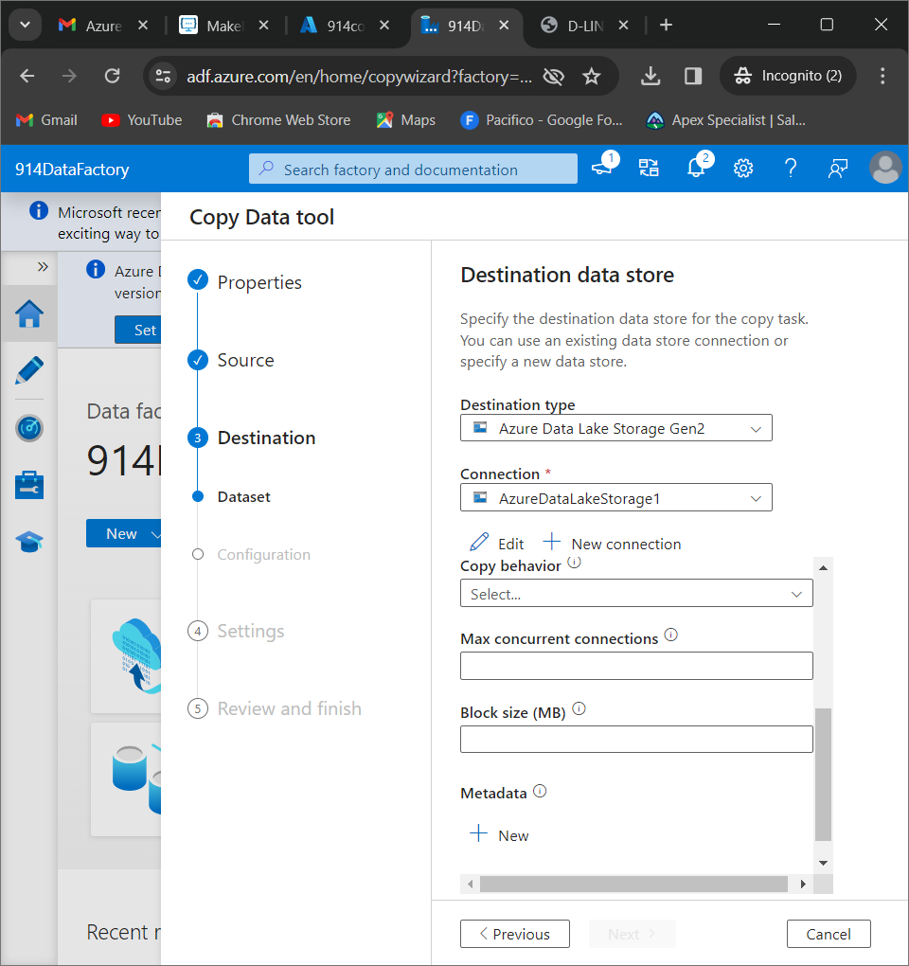

Give the task name as “CopyPipeline_Chakradhar”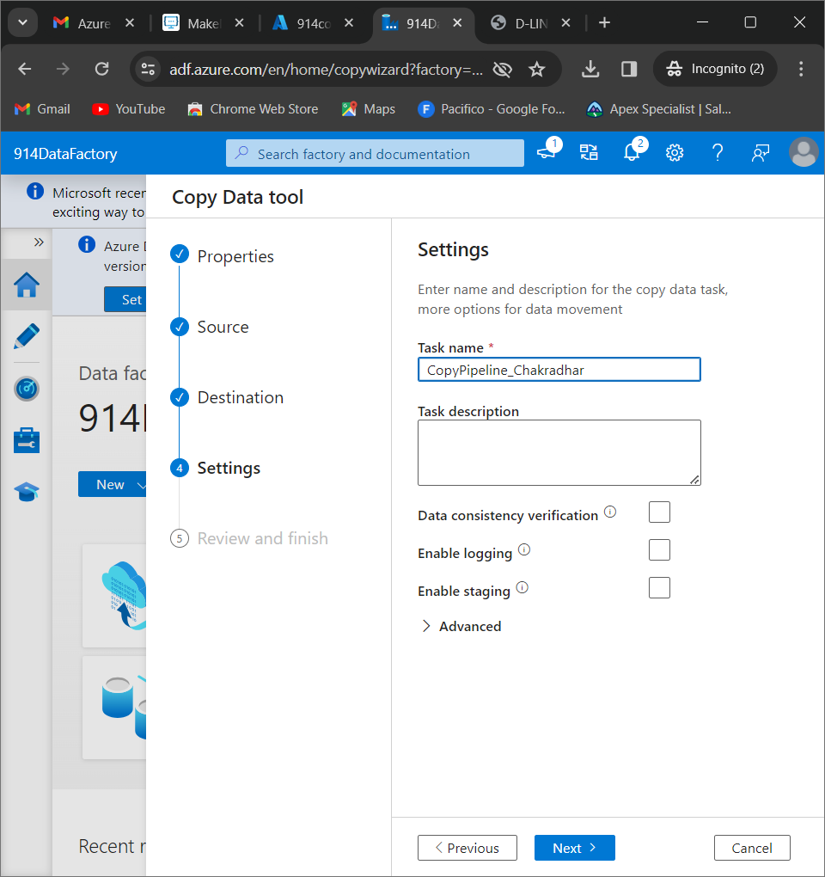

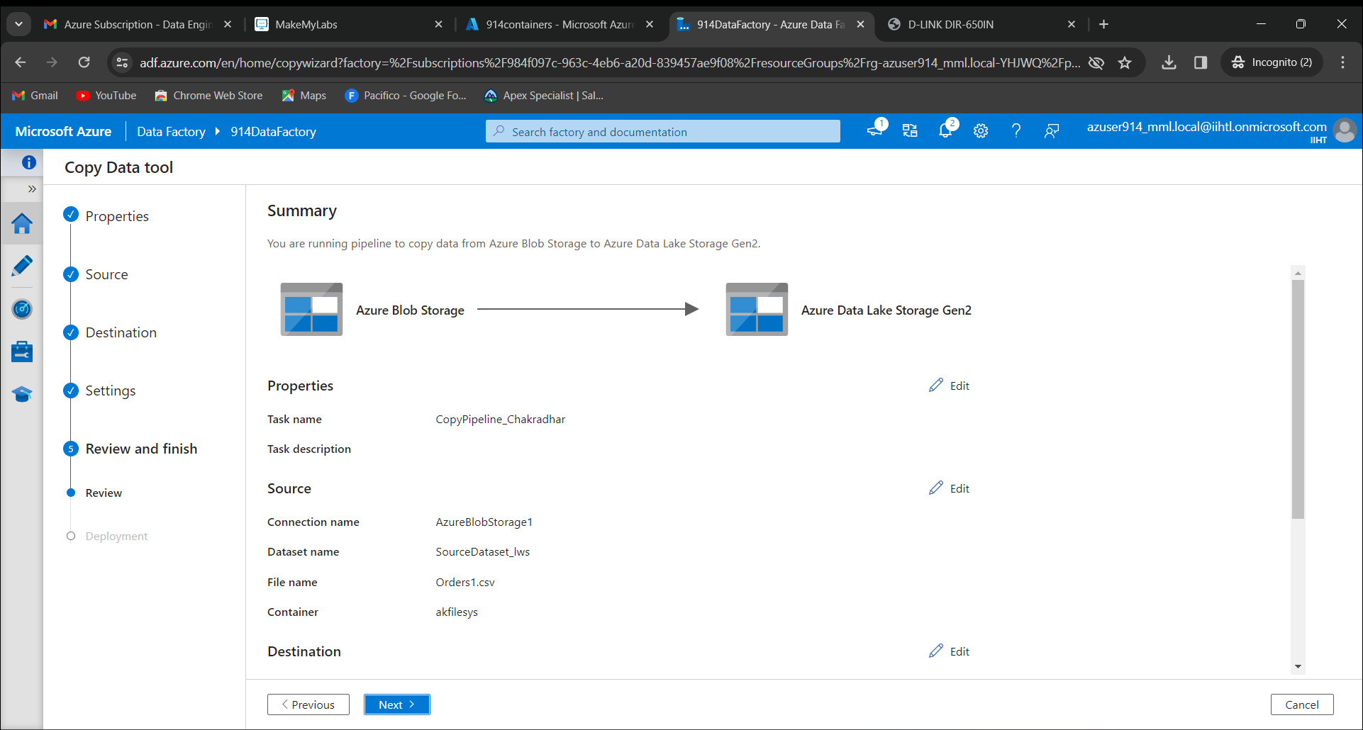

Click on Finish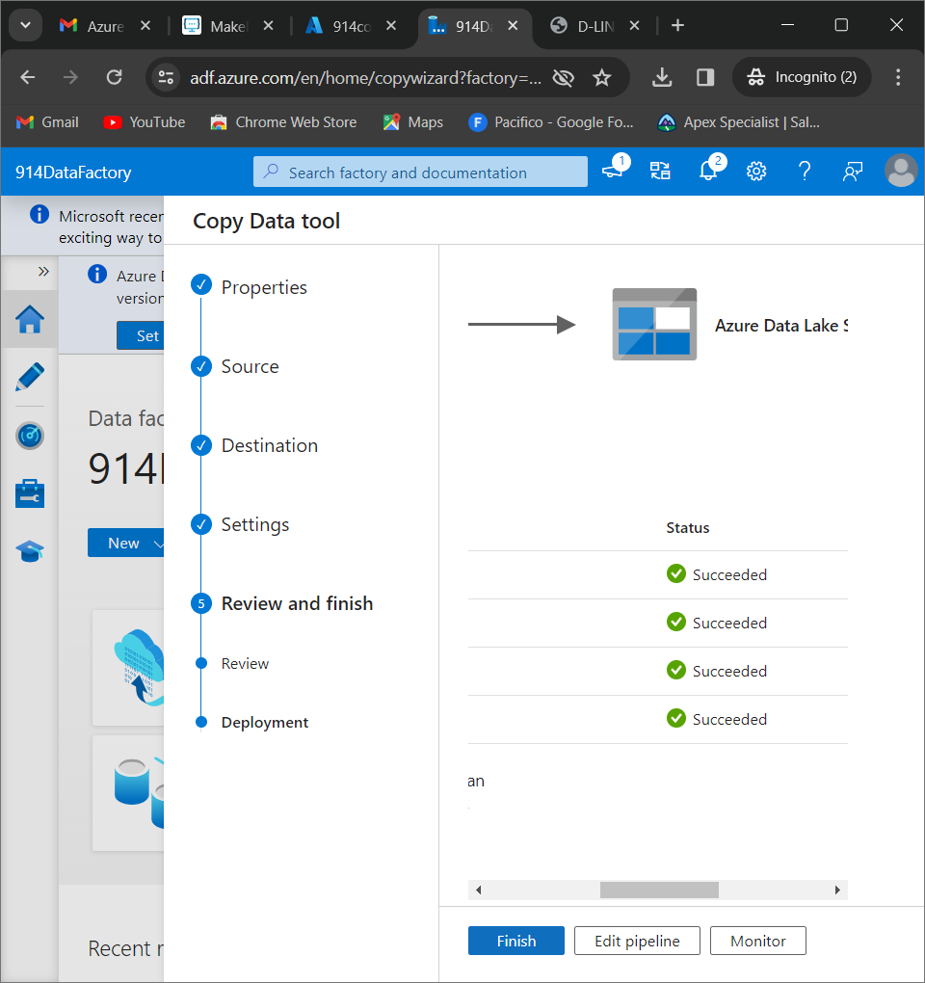

In 914containers, upload some files from local 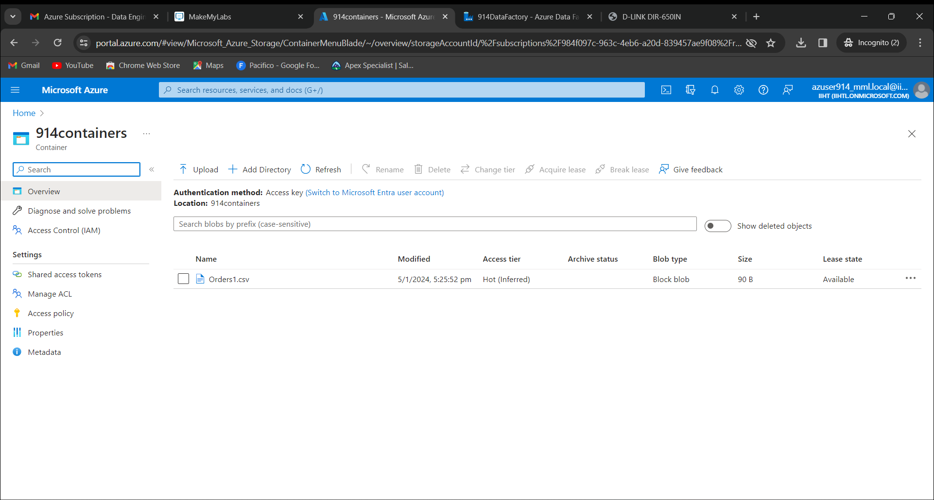

Click on upload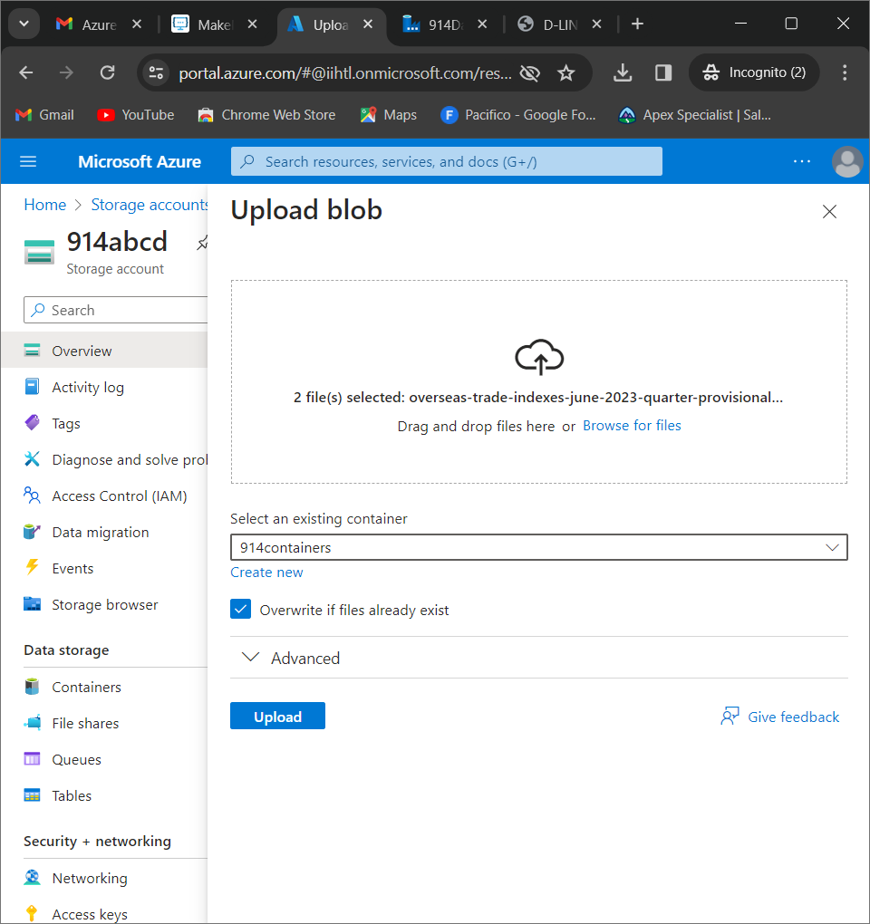

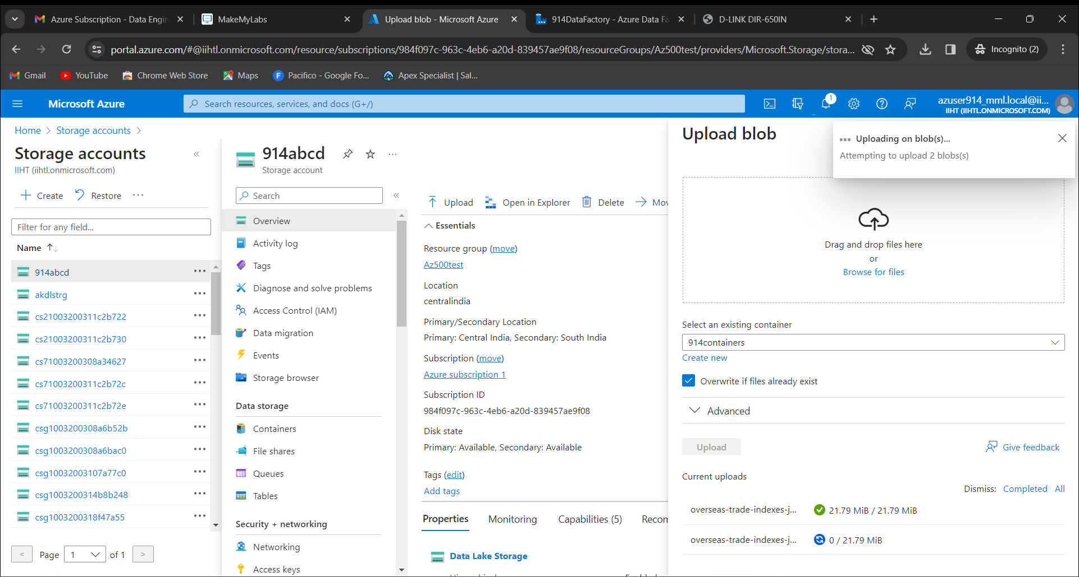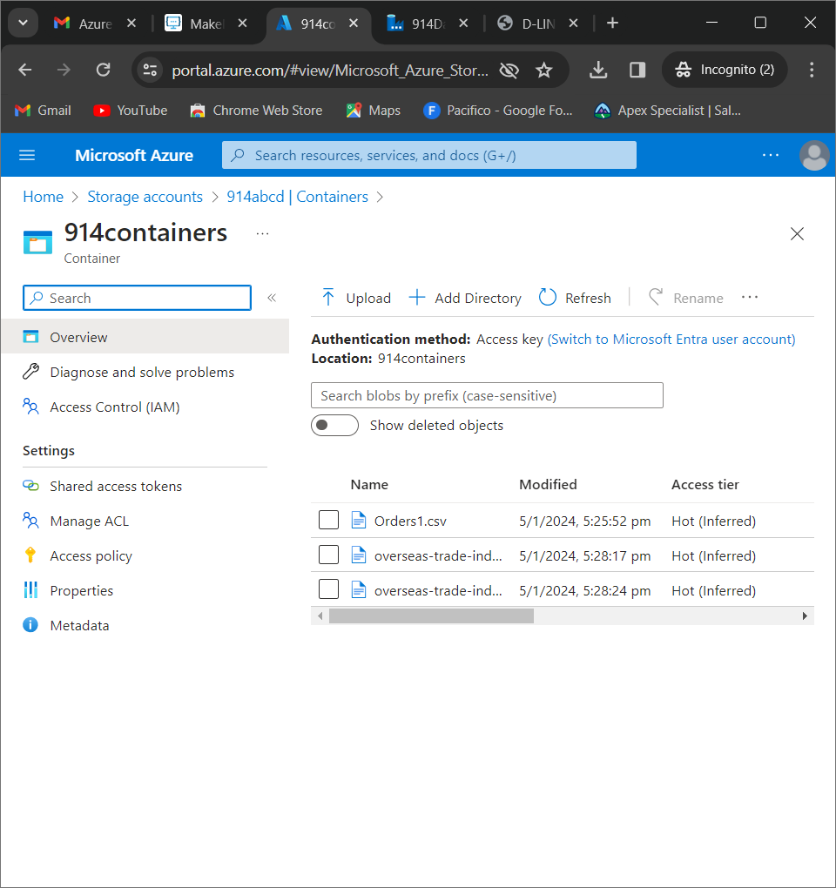

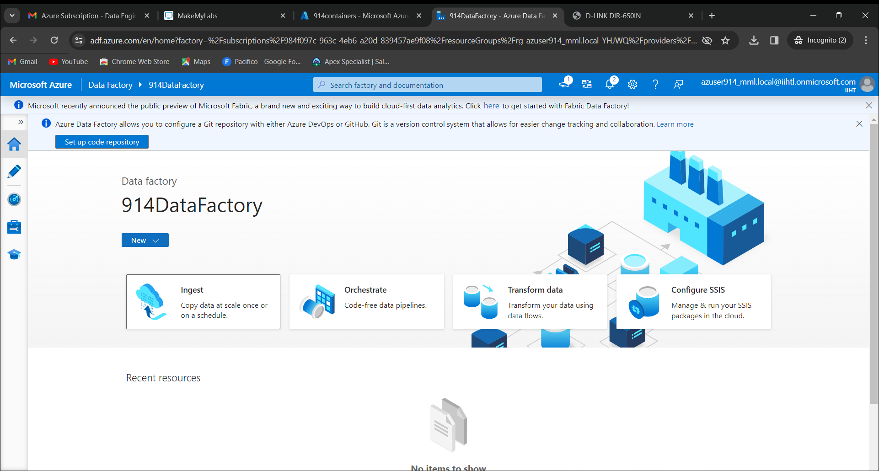

Click on pipelines named as “CopyPipeline_Chakradhar”

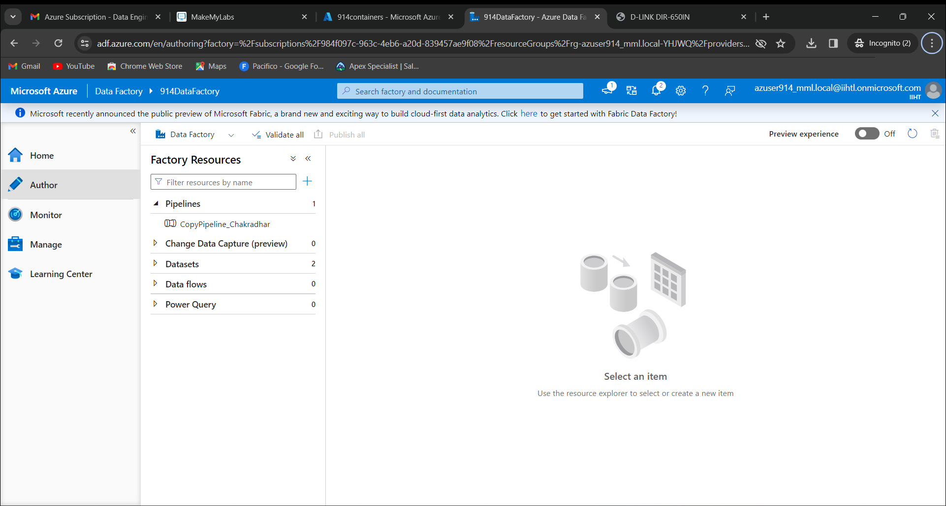

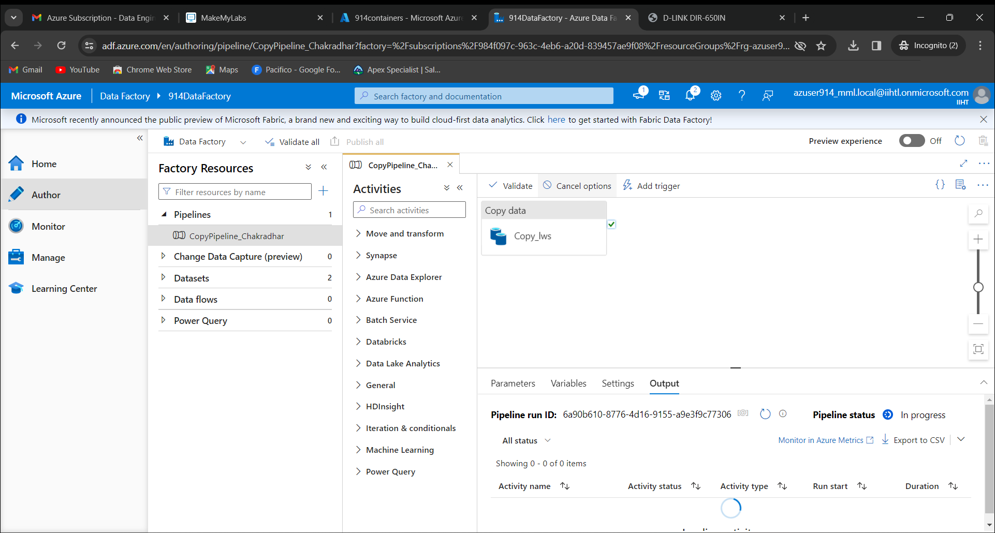

Click on Validate

